DBMS PROJECT

**TOPIC: RAILWAY MANAGEMENT SYSTEM**

1. B. Harshavardhan 21EEB0A13

2. C. Abhinay 21EEB0A18

**Problem Statement: -**

The **Railway Management System** project is a database management system project that aims to provide a platform for managing the data related to railway reservations. The project includes various tables such as User, Train Details, Transaction Details, Passengers Details, etc. These tables store information about users, trains, transactions, passengers, etc...

If users have already registered and logged into the system, the system allows them to manage the data related to the availability of seats in trains, booked tickets and other related information.

The system assumes that the information entered by the users is correct, and the seat availability information is up-to-date. The cancellation and refund policy of the system is also assumed to be well-defined and transparent to the users.

Overall, the Railway Management System project is a comprehensive solution that simplifies the process of managing railway reservations data for both users and administrators, with the below-mentioned assumptions.

Assumptions:

* Every train is assumed to run every day.
* Each User may reserve an unlimited number of tickets.
* All Compartments of a certain class type are grouped together under a single name (for example, B1, B2... are regarded to be 3A, etc.).
* Any number of passengers may book their seats using a single ticket id.

**Tables: -**

User

|  |  |  |
| --- | --- | --- |
| Attribute | Data type | Constraints and Characteristics |
| UserId | VARCHAR(20) | Primary key |
| Password | VARCHAR(20) | Not null |
| UserEmail | VARCHAR(40) | Unique, not null |
| DateoFBirth | DATE | Not null |
| Age | INT | Not null |
| UserName | VARCHAR(30) | Not null |

Station

|  |  |  |
| --- | --- | --- |
| Attribute | Data type | Constraints and Characteristics |
| StationCode | VARCHAR(8) | Primary key |
| StationName | VARCHAR(20) | Not null |

Class

|  |  |  |
| --- | --- | --- |
| Attribute | Data type | Constraints and Characteristics |
| ClassCode | VARCHAR(5) | Primary key |
| ClassName | VARCHAR(20) | Not null |

Train

|  |  |  |
| --- | --- | --- |
| Attribute | Data type | Constraints and Characteristics |
| TrainNo | NUMBER(5) | Primary key |
| TrainName | VARCHAR(20) | Not null |
| StartingStation | VARCHAR(8) | Not null |
| Destination | VARCHAR(8) | Not null |
| Distance | INT | - |

Transaction

|  |  |  |
| --- | --- | --- |
| Attribute | Data type | Constraints and Characteristics |
| TransactionId | VARCHAR(64) | Primary key |
| ModeOfPayment | VARCHAR(20) | Not null |
| PaymentStatus | VARCHAR(15) | Not null |
| PaymentDate | DATE | Not null |
| Amount | INT | Not null |
| UserId | VARCHAR(20) | Foreign key, not null |

Ticket

|  |  |  |
| --- | --- | --- |
| Attribute | Data type | Constraints and Characteristics |
| TicketId | NUMBER(10) | Primary key |
| NoOfPassengers | INT | Not null |
| StartingStation | VARCHAR(8) | Not null |
| Destination | VARCHAR(8) | Not null |
| TransactionId | VARCHAR(64) | Foreign key (1) , not null |
| TrainNo | NUMBER(5) | Foreign key (2), Not null |

Passenger

|  |  |  |
| --- | --- | --- |
| Attribute | Data type | Constraints and Characteristics |
| First_Name | VARCHAR(20) | Not null |
| Last_Name | VARCHAR(20) | Not null |
| StartingStation | VARCHAR(8) | Not null |
| Destination | VARCHAR(8) | Not null |
| Age | INT | Not null |
| SeatNo | INT | Primary key (1), Not null |
| ClassCode | VARCHAR(5) | Primary key (2), Foreign key(1), Not null |
| TrainNo | NUMBER(5) | Primary key (3), Foreign key (2), Not null |
| TicketId | BIGINT | Foreign key (3), Not null |

Seats

|  |  |  |
| --- | --- | --- |
| Attribute | Data type | Constraints and Characteristics |
| TrainNo | NUMBER(5) | Primary key(1),Foreign key(1) |
| ClassCode | VARCHAR(5) | Primary key (2), Foreign key (2) |
| NoOfSeats | INT | Not null |

Stoppage

|  |  |  |
| --- | --- | --- |
| Attribute | Data type | Constraints and Characteristics |
| StationCode | VARCHAR(8) | Primary key (1), Foreign key (1) |
| TrainNo | NUMBER(5) | Primary key (2), Foreign key (2) |
| ArrivalTime | TIME | Not null |
| DepartureTime | TIME | Not null |

**Functional Dependencies and Primary key: -**

1)User: -

UserId-> {DateOfBirth, UserEmail, Password, Age,UserName} .

Since all the fields depend on UserId, (UserId)+ -> **R**.

Hence, UserId is a Primary Key.

2)Station: -

StationCode-> { StationName} .

Since all the fields depend on StationCode, (StationCode)+ -> **R**.

Hence, StationCode is a Primary Key.

3)Class: -

ClassCode-> { ClassName} .

Since all the fields depend on ClassCode, (ClassCode)+ -> **R**.

Hence, ClassCode is a Primary Key.

4)Train: -

TrainNo-> { TrainName, StartingStation, Destination, Distance} .

Since all the fields depend on TrainNo, (TrainNo)+ -> **R**.

Hence, TrainNo is a Primary Key.

5)Transaction: -

TransactionId-> { ModeOfPayment, PaymentStatus, PaymentDate, Amount, UserId } .

Since all the fields depend on TransactionId, (TransactionId)+ -> **R**.

Hence, TransactionId is a Primary Key.

6)Ticket: -

TicketId-> { NoOfPassengers, StartingStation, Destination, TransactionId, TrainNo } .

Since all the fields depend on TicketId, (TicketId)+ -> **R**.

Hence, TicketId is a Primary Key.

7)Passenger: -

{TrainNo, ClassCode, SeatNo}-> { First_Name, Last_Name, StartingStation, Destination, Age, TicketId } .

Since all the fields depend on { TrainNo,ClassCode,SeatNo },

({TrainNo, ClassCode, SeatNo})+ -> **R**.

Hence, {TrainNo, ClassCode, SeatNo} is Combinedly a Composite Primary Key.

8)Seats: -

{ClassCode, TrainNo}-> { NoOfSeats} .

Since all the fields depend on {ClassCode, TrainNo}, ({ClassCode, TrainNo})+ -> **R**.

Hence, {ClassCode, TrainNo} is Combinedly a Composite Primary Key.

8)Stoppage: -

{StationCode, TrainNo}-> { ArrivalTime, DepatureTime} .

Since all the fields depend on {StationCode, TrainNo}, ({StationCode, TrainNo})+ -> **R**.

Hence, {StationCode, TrainNo} is Combinedly a Composite Primary Key.

**Normalisation: -**

1)User: -

Primary key: UserId.

All attributes depend on the UserId, hence the table is in 2NF.

All attributes depend directly on UserId, hence the table is in 3NF.

All determinants (UserId) are Super key, hence the table is in BCNF.

2)Station: -

Primary key: StationCode.

All attributes depend on the StationCode, hence the table is in 2NF.

All attributes depend directly on StationCode, hence the table is in 3NF.

All determinants (StationCode) are Super key, hence the table is in BCNF.

3)Class: -

Primary key: ClassCode.

All attributes depend on the ClassCode, hence the table is in 2NF.

All attributes depend directly on ClassCode, hence the table is in 3NF.

All determinants (ClassCode) are Super key, hence the table is in BCNF.

4)Train: -

Primary key: TrainNo.

All attributes depend on the TrainNo, hence the table is in 2NF.

All attributes depend directly on TrainNo, hence the table is in 3NF.

All determinants (TrainNo) are Super key, hence the table is in BCNF.

5)Transaction: -

Primary key: TransactionId.

All attributes depend on the TransactionId, hence the table is in 2NF.

All attributes depend directly on TransactionId, hence the table is in 3NF.

All determinants (TransactionId) are Super key, hence the table is in BCNF.

6)Ticket: -

Primary key: TicketId.

All attributes depend on the TicketId, hence the table is in 2NF.

All attributes depend directly on TicketId, hence the table is in 3NF.

All determinants (TicketId) are Super key, hence the table is in BCNF.

7)Passenger: -

Primary key: TrainNo, ClassCode, SeatNo.

All attributes depend on the TrainNo, ClassCode, SeatNo, hence the table is in 2NF.

All attributes depend directly on TrainNo, ClassCode, SeatNo, hence the table is in 3NF.

All determinants (TrainNo, ClassCode, SeatNo) is Super key, hence the table is in BCNF.

8)Seats: -

Primary key: TrainNo, ClassCode.

All attributes depend on the TrainNo, ClassCode, hence the table is in 2NF.

All attributes depend directly on TrainNo, ClassCode, hence the table is in 3NF.

All determinants (TrainNo, ClassCode) are Super key, hence the table is in BCNF.

8)Stoppage: -

Primary key: TrainNo, StationCode.

All attributes depend on the TrainNo, StationCode, hence the table is in 2NF.

All attributes depend directly on TrainNo, StationCode, hence the table is in 3NF.

All determinants (TrainNo, StationCode) are Super key, hence the table is in BCNF.

**ER Diagram: -**

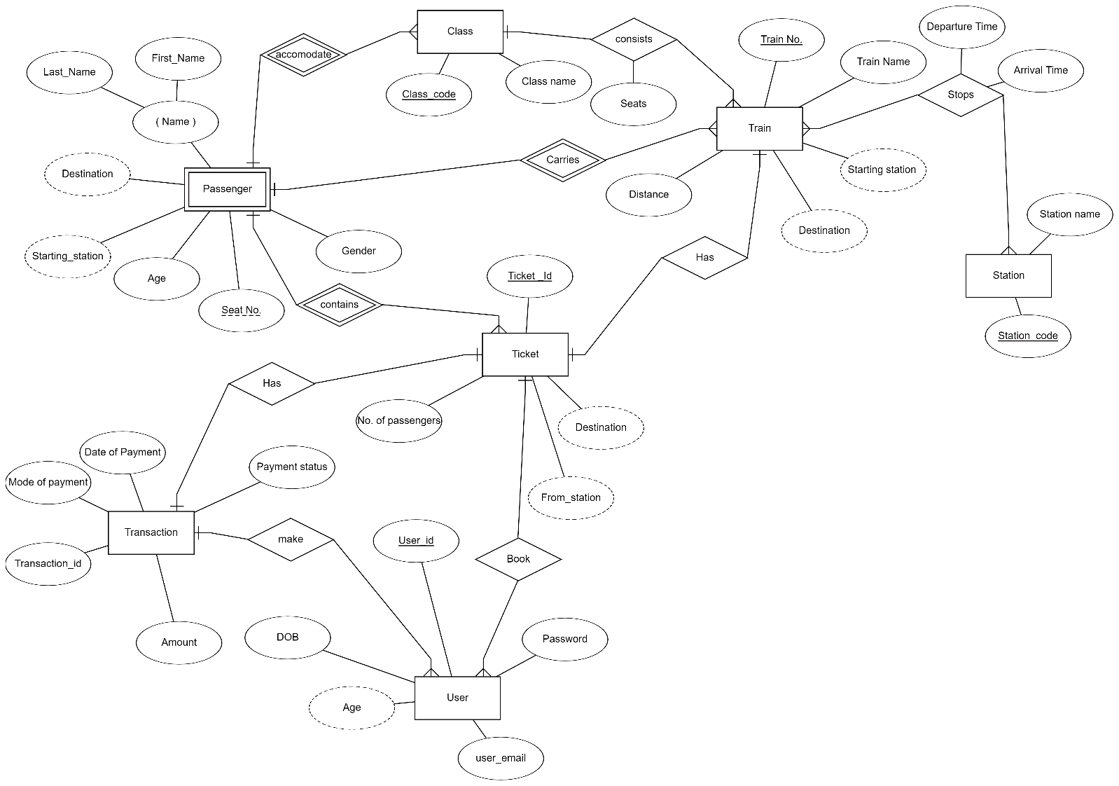

**Relational Schema with Normalised Tables: -**

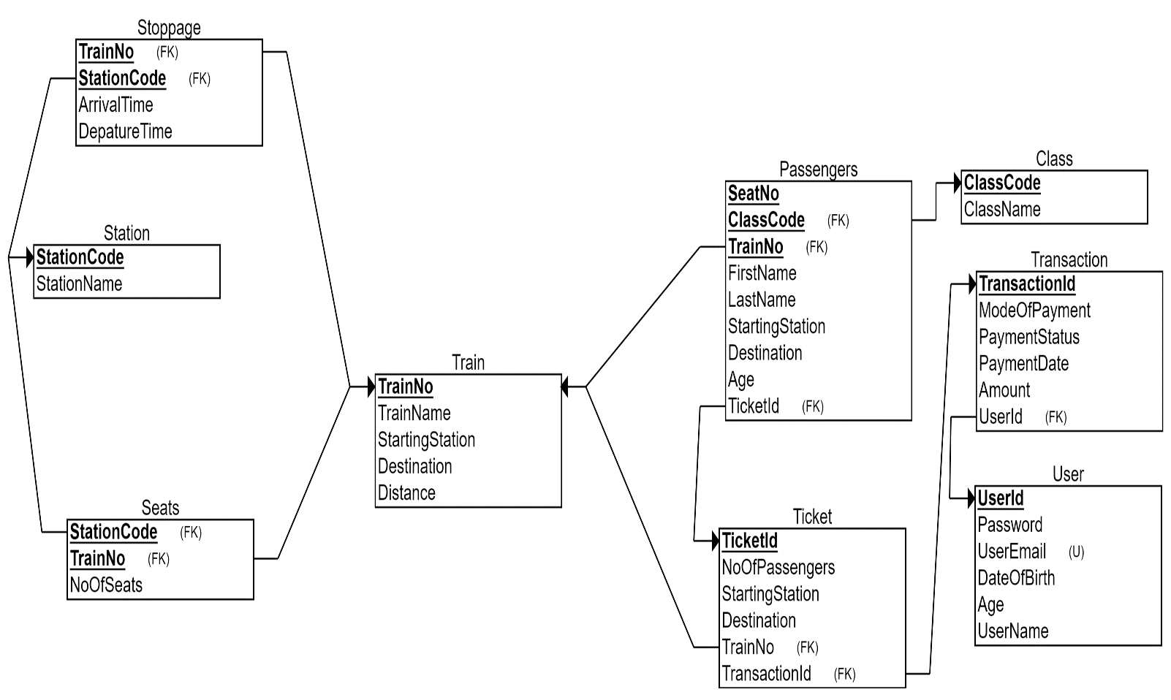

**SQL Codes**

**Creating tables: -**

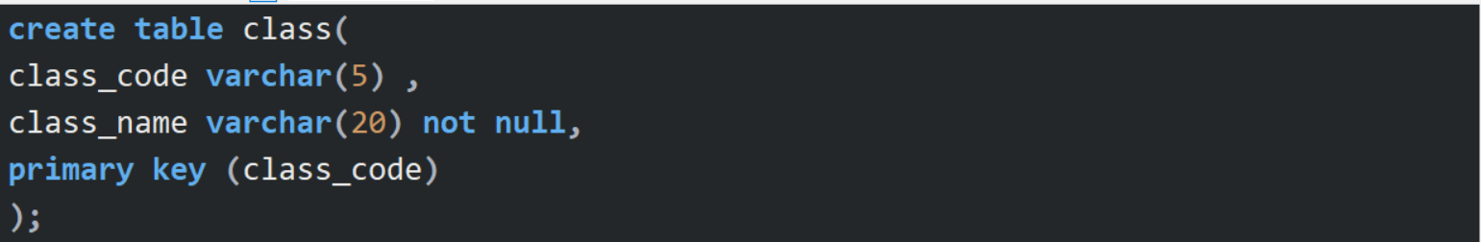

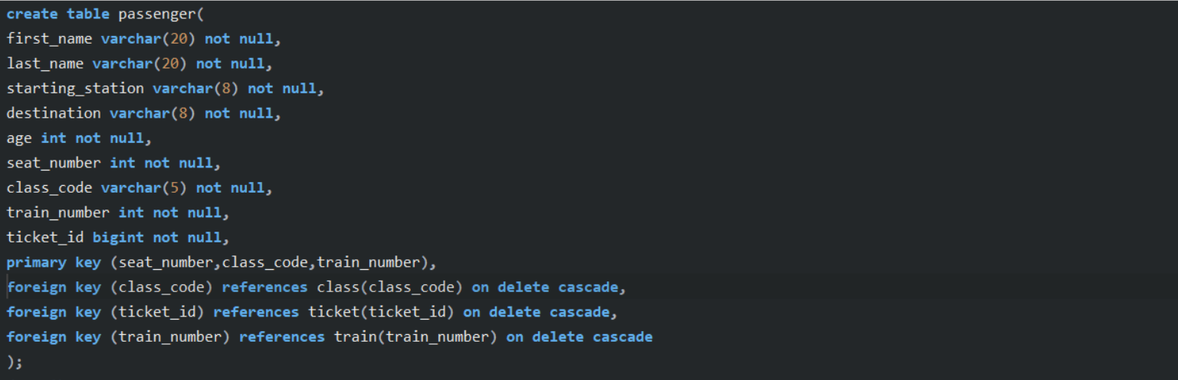

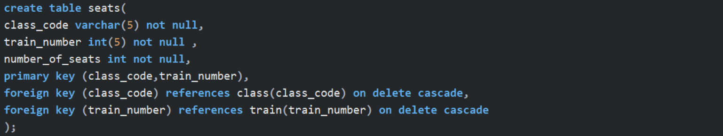

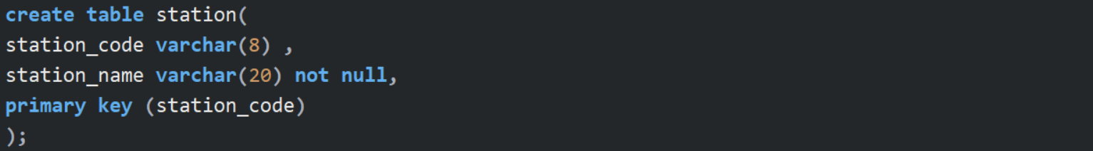

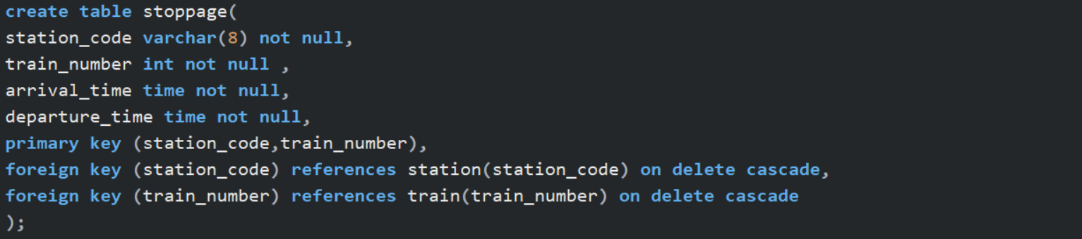

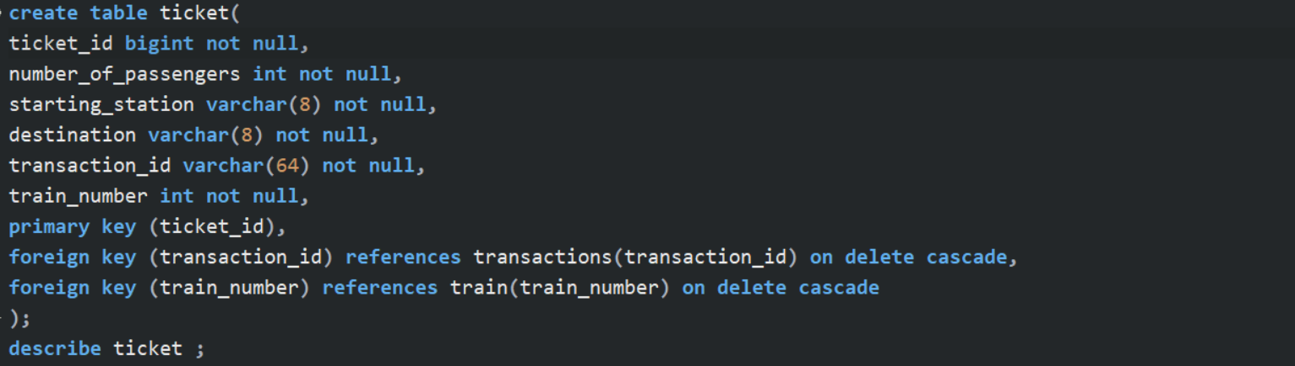

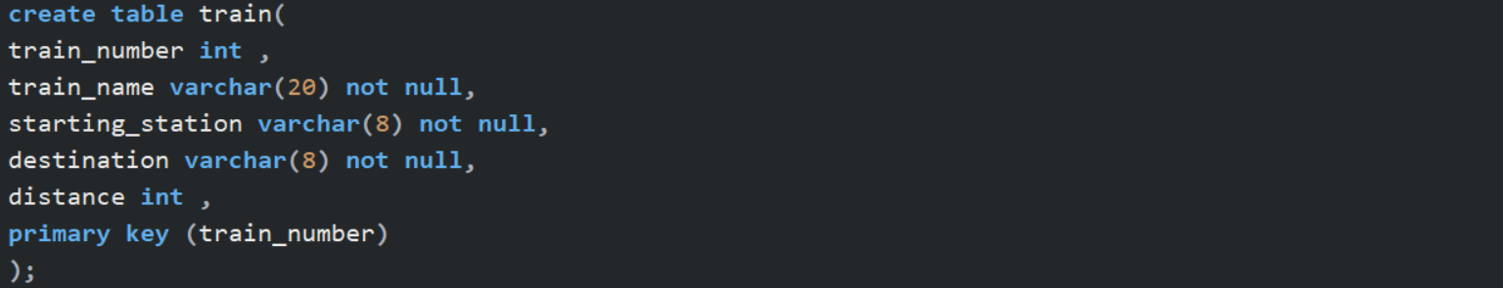

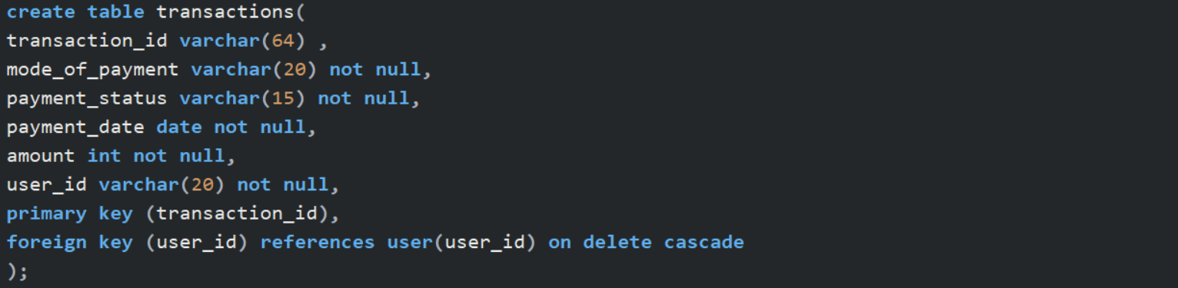

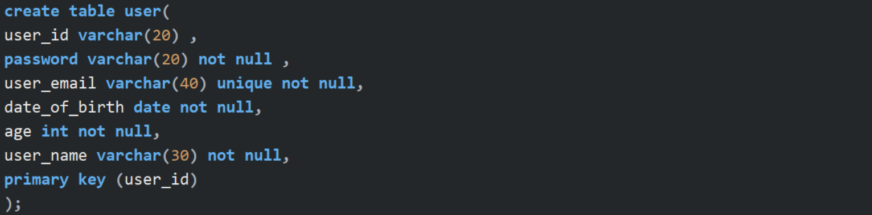

**Inserting Data: -**



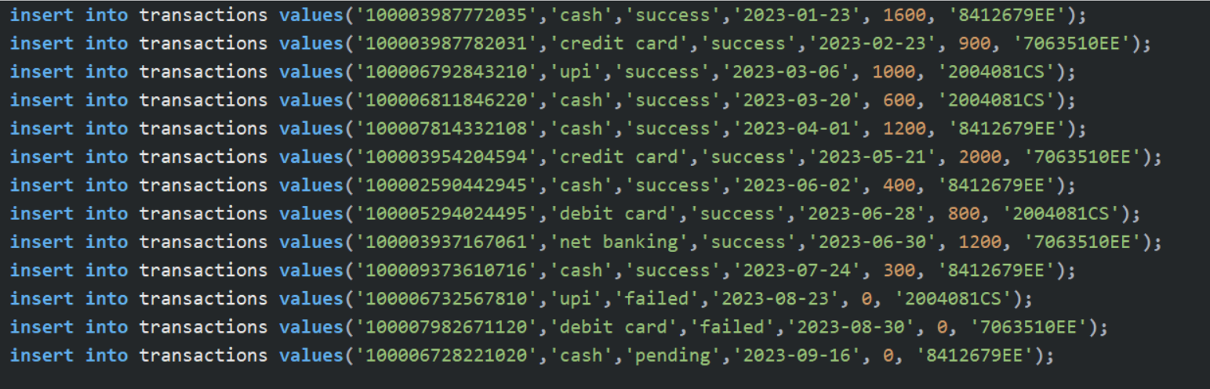

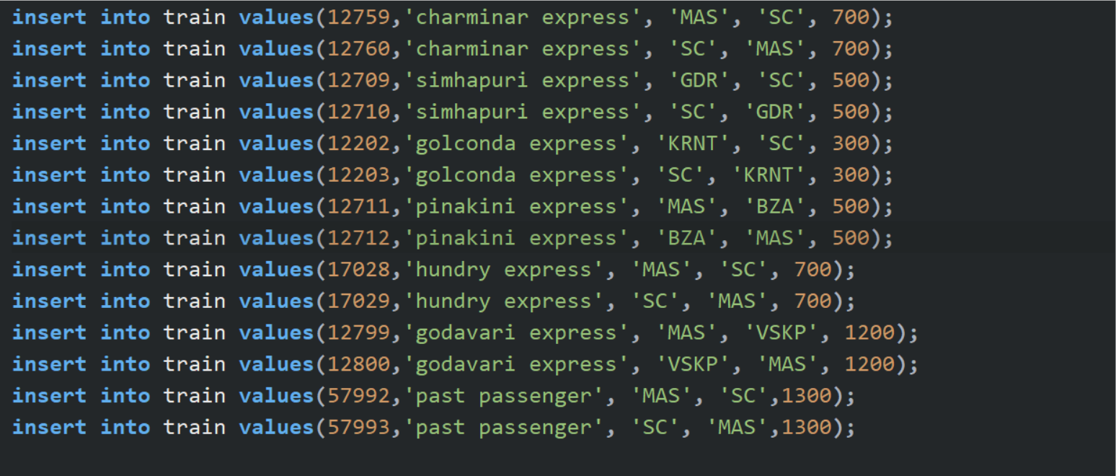

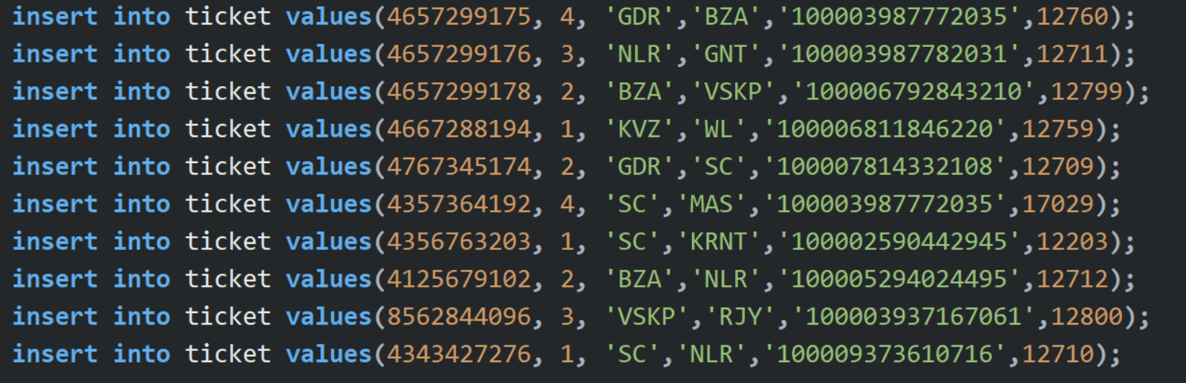

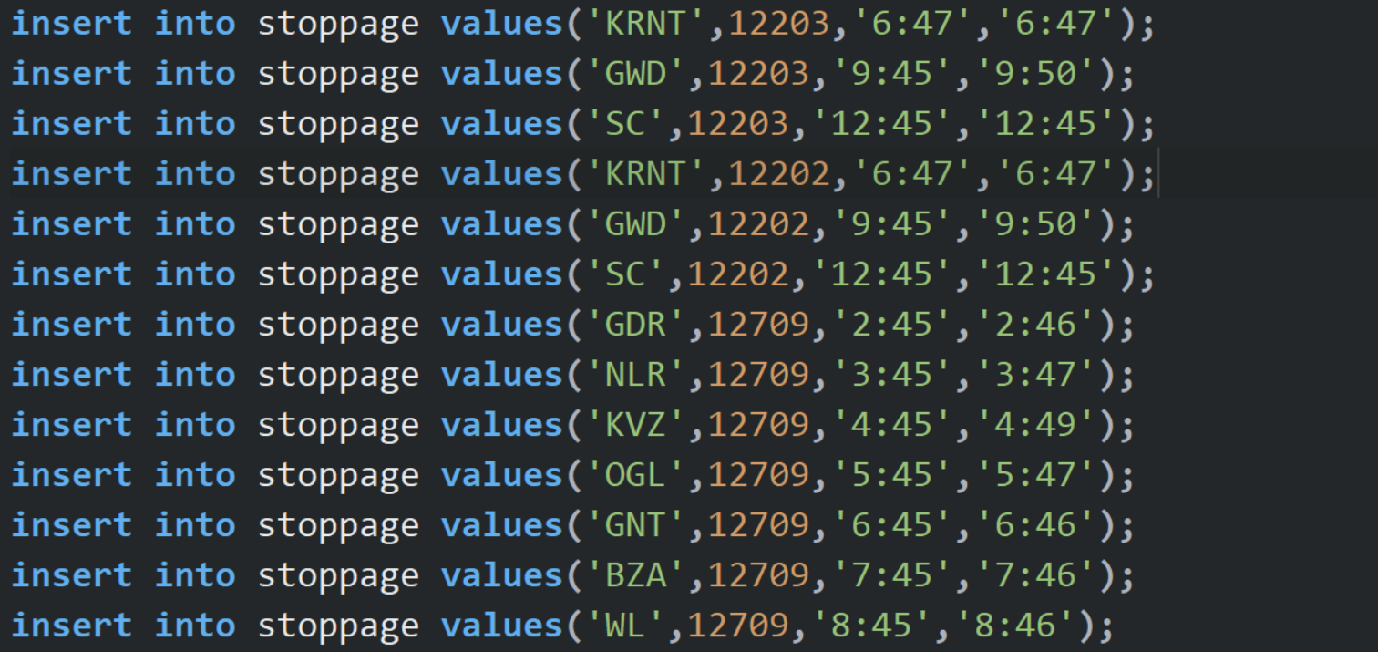

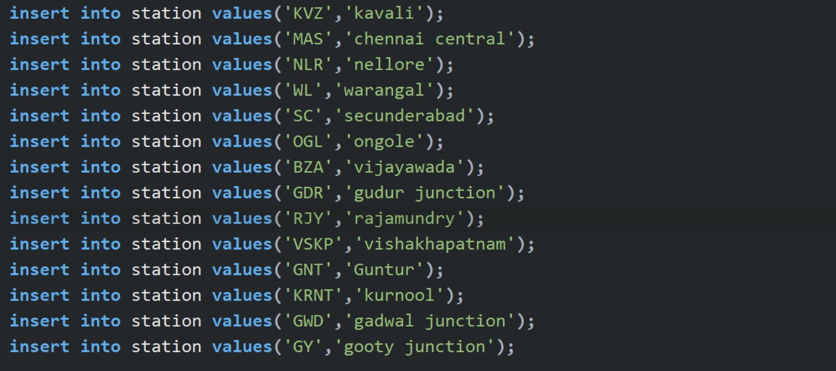

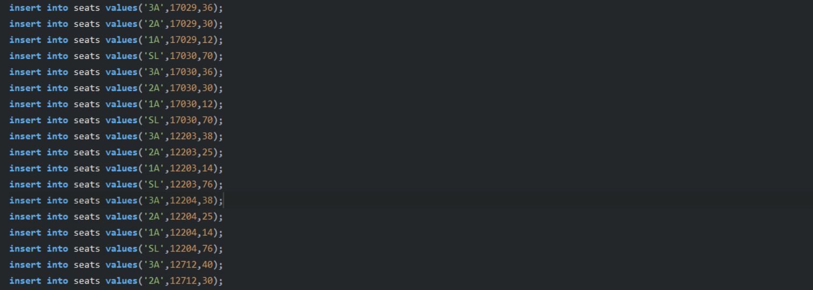

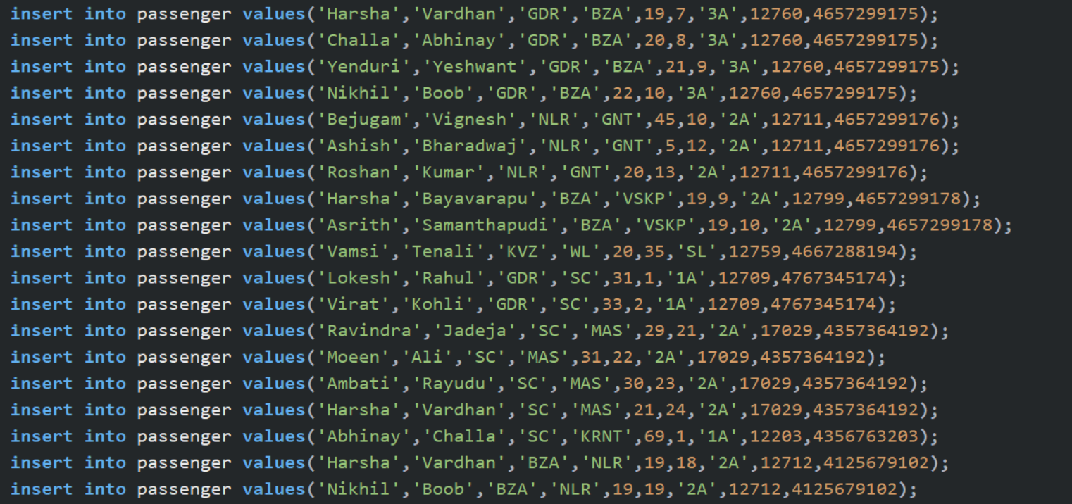

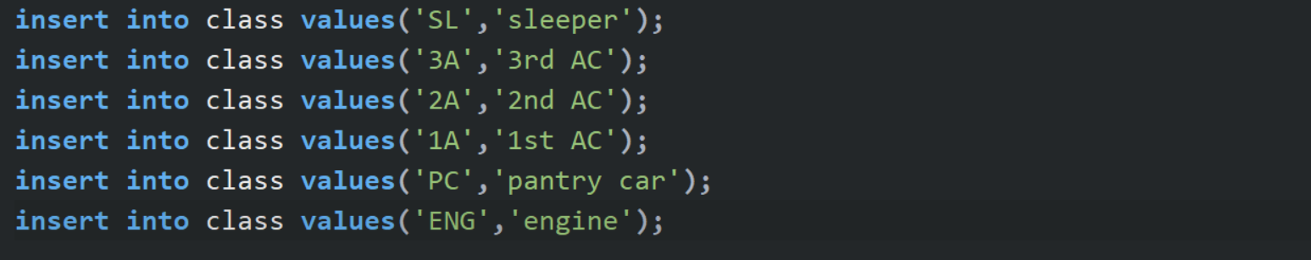

**Tables created**

User

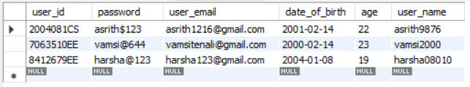

Station

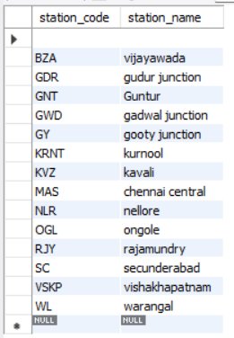

Class

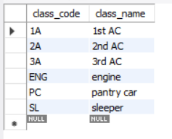

Train

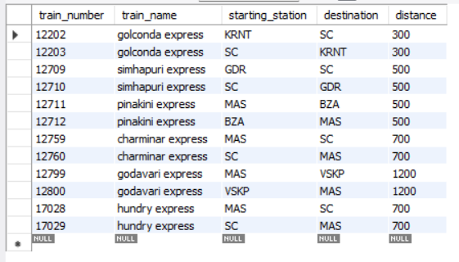

Transaction

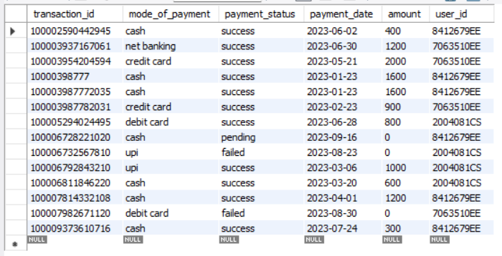

Ticket

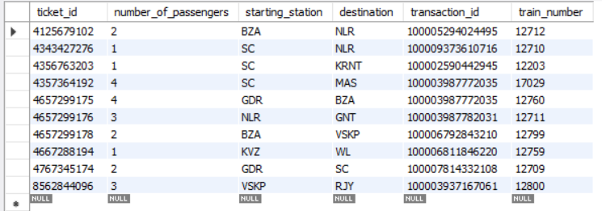

Passenger

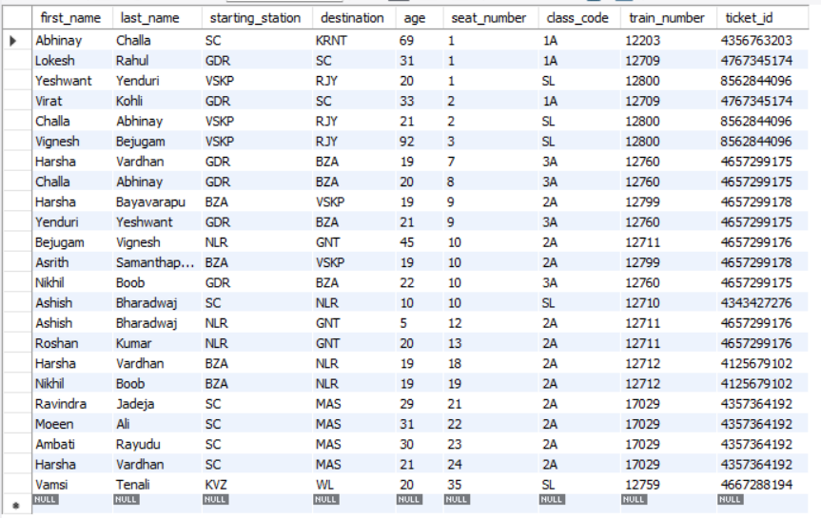

Seats

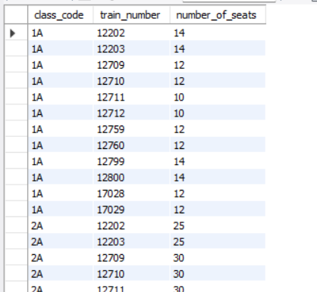

Stoppage

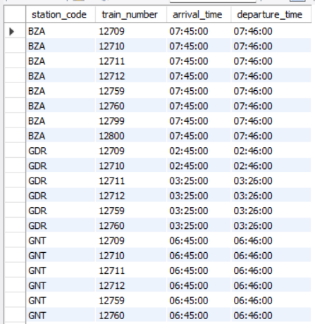

THANK YOU